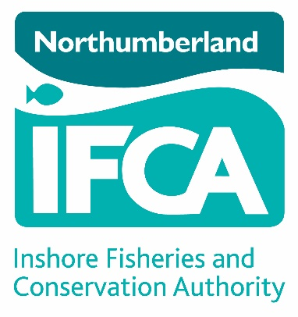

Dispensation Request to the Northumberland Inshore Fisheries and Conservation Authority (NIFCA)

How to use this form
Important: before you complete this form, please read our bye-laws (available at www.nifca.gov.uk) If you need further guidance please contact the Northumberland IFCA office on 01670 797676.

- This form should be completed if you wish to request a dispensation from the Northumberland IFCA under one of the NIFCA byelaws (where appropriate).

- Complete all sections of the form.

- The details in this form can be handwritten OR typed. If handwritten, please use black ink and BLOCK letters. Any alterations must be initialled and dated. Do NOT use correction fluid and if you require more space for any section, please continue on a separate sheet, ensuring that you sign and date each sheet.

- When completed please return to the NIFCA office at 8 Ennerdale Road, Blyth, Northumberland or by email marked ‘Dispensation Request’ to nifca@nifca.gov.uk

- You must not carry out the activity for which the dispensation is required until this completed form has been sent to the Northumberland IFCA and approved. Approval can take up to 56 working days but is usually quicker. We are a small organisation. If you complete your application fully, we will be able to respond to your request in a timely manner.

SECTION 1:
DETAILS OF APPLICANT

Name of Applicant(s)
Title | Forename | Surname

Business Name
Correspondence Address
Postcode
Office number
Mobil Number
Email Address

SECTION 2:
REQUEST FOR DEROGATION

From which byelaw(s) are you seeking dispensation?

Location: where will this activity take place?
Please provide GIS Shape files (.tab or .shp) wherever possible and attach them to the application or, if sending co-ordinates please give them in Latitude/Longitude Decimal Degrees.

Will the activity take place within a Marine Protected Area?

☐ Yes ☐ No

If yes, which site?

Timetable
Please provide details of the timetable for this project. Continue on a separate sheet if necessary and attach it to the application.

Details of the Vessel Being Used
Vessel Name
Registry of shipping Number
PLN
Owner of Vessel
Skipper of Vessel

Gear Description
(please include details such as mesh size, tow speed and duration)

Details of activity
Please give a description of the proposed activity including its purpose.
Continue on a separate sheet if necessary.

Mitigation
Please give details of any mitigation taken to minimise the impact of the proposed activity.
Continue on a separate sheet if necessary

SECTION 3:
APPLICANT DECLARATION

Please enter the number of continuation sheets used in the box
Please enter the number of supporting documents in the box

Declaration:
I/we declare that I/we have read and understand the Northumberland IFCA byelaws and have complied with them, except as otherwise approved by the Northumberland IFCA. The information given in this form is to the best of my/our knowledge correct and I/we accept full responsibility for it.

☐ I/We agree to share any findings and data with Northumberland IFCA.
☐ I/We do not agree to share any findings and data with Northumberland IFCA.

This declaration must be signed by all signatories to the agreement.

Name in BLOCK capitals | Signature | Date

WARNING:

If you knowingly or recklessly make a false or misleading statement for yourself or anyone else, you risk prosecution.

General Data Protection Regulations

Information contained within this application form will be held on a database that is shared with partner organisations and may be verified with other government departments to confirm accuracy or detect crime. Further details of NIFCA’s Privacy Policy can be viewed at: https://www.nifca.gov.uk/wp-content/uploads/2013/02/NIFCA-Privacy-Notice.pdf

