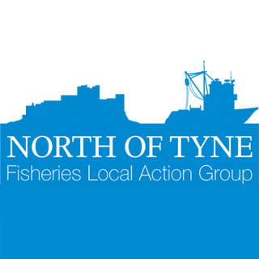

**Stock status assessment for the *Cancer pagurus* fishery of the Northumberland Coast in 2019.**

**Report produced by Andrew Boon**

**Contents**

Abstract 3

1. Introduction 3

2. Background to the Fishery 3

3. Current Fisheries Management 5

3.1 Regional Management 5

3.2 Wider Management 6

4. Methodology 6

4.1 Shore-based sampling 6

4.2 Offshore sampling 7

4.3 Analysis 7

5. Results 8

5.1 Size of Maturity 8

5.2 Length-Weight Relationship 9

5.3 Survivability 10

5.4 Population Biometrics 11

5.5 Stock Status 12

6. Discussion 13

6.1 Size of Maturity 13

6.2 Length-Weight Relationship 13

6.3 Survivability 14

6.4 Population Biometrics 14

6.5 Stock Status 14

7. Recommendations 15

7.1 Future Monitoring 15

7.2 Future Management 15

8. Conclusions 16

9. References 16

10. Appendix 17

**Acknowledgements**

I would like to express my gratitude for all the local fishermen within the NIFCA district that helped facilitate the data collection throguhout this project, the European Maritime Fisheries Fund for providing the financial backing for the project, as well as NIFCA and the North of Tyne FLAG for their support and contacts with the local industry.Without the help of these partners, this project would not have been possible.

# Abstract

Spanning a 12-month period in 2019, this study aimed to assess the current conservation status of the *Cancer pagurus* fishery within the Northumberland Inshore Fisheries Conservation Authority (NIFCA) district. A shore and offshore-based sampling regime allowed for a comprehensive assessment of the stock to be completed. After analysis, the stock status for both male and female *C. pagurus* fell short of achieving the target of maximum sustainable yield. This conforms to trends reported in the Cefas stock assessment for the Central North Sea stock unit in 2017. Assessments of future management implications for the stock status of the *C. pagurus* fishery of the NIFCA district highlighted the recommendation of an increase in the Minimum Conservation Reference Size to 140mm.

# Introduction

This report is the culmination of a 15-month project funded by the European Maritime Fisheries Fund (EMFF), facilitated by the North of Tyne Fisheries Local Action Group (FLAG) and hosted by Northumberland Inshore Fisheries Conservation Authority (NIFCA). The goal of this project was to conduct a robust and comprehensive stock assessment and assess the conservation status of the brown crab, *Cancer pagurus*, fishery within the NIFCA district.

The North of Tyne FLAG was established in 2016, alongside 5 other such bodies around the English coast, using EMFF funding and came to an end in January 2020. The North of Tyne FLAG aim has been translated into four key objectives (EU, 2020):

* Engaging with fishermen, the fishing industry and communities to produce projects that support the sustainable development of fishing and aquaculture.
* Bringing together a partnership of public, private, voluntary and community sector representatives to support the delivery of the strategy - delivering a community-led local development approach in the context of fishing and aquaculture.
* Ensuring the economic viability of fishermen’s livelihoods, supporting the diversification of local economies dependent on fisheries and aquaculture into other sectors of the marine economy, and driving sustainable economic growth.
* Fostering implementation of the reformed common fisheries policy (CFP).

This project provided an opportunity for the North of Tyne FLAG to help facilitate collaborative research between fishermen and scientists, one of the key priorities for the EMFF.

# Background to the Fishery

Current information on brown crab (*Cancer* pagurus) stocks important to the NIFCA district is limited. It comes from landings declarations (Monthly Activity Shellfish Returns forms and NIFCA permit returns) and from the Centre for Environment, Fisheries and Aquaculture Science (CEFAS) stock assessments. Both have limitations in terms of assessments of stocks within the NIFCA district. Landings declarations only give information on the proportion of the catch legal and desirable to land which therefore excludes undersized, soft and egg bearing (berried) brown crab which can account for a considerable proportion of catch at certain times of year. CEFAS assessments are also largely based on a relatively small number of landings and scaled up to represent all landings (CEFAS, 2017) which may not accurately represent the catch. Further, CEFAS assessments are undertaken over a larger area than the Northumberland IFCA district (CEFAS 2017).

In 2019 there were 95 NIFCA Commercial Shellfish Holders, of which 86 actively fished pots within the NIFCA district. Potting vessels include traditional beach-launched cobles, modern fiberglass fast planing vessels and multi-hull catamarans (Browne, 2012). The potting fishery is a multispecies fishery targeting predominantly European lobster (*Homarus gammarus*), brown crab (*C. pagurus*), velvet crab (*Necora puber*) and prawns (*Nephrops norvegicus*). Target species are fished using pots, which are fished in “fleets” of 20–40. Pots are baited and deployed, and typically left to soak for one to two days. Potting vessels in the district are between 4 and 12 m in length (NIFCA Data, 2019), with 85% of vessels under 10m in length. Lobster forms the most economically valuable part of the catch, thus is preferentially targeted by fishers, particularly during peak lobster season, July-October (Turner *et al.,* 2014). Outside peak lobster season, pots are often deployed on different ground types to target other species (Garside *et al*., 2004). A number of vessels operate pots seasonally or part-time, together with other fishing gear or occupations (Turner *et al.,* 2014).



Figure : Landed weight of *C. pagurus* by vessels fishing within the NIFCA district between 2011 and 2019, taken from NIFCA permit returns.



Figure : Annual average landings per unit effort (LPUE) in kg per 100 pots hauled within the NIFCA district between 2011 and 2019, taken from NIFCA permit returns.



Figure : Annual number of pots hauled by vessels within the NIFCA district between 2011 and 2019, taken from NIFCA permit returns.

For the analysis of trends in landings and effort, consistent data is available since 2011, when a new permit return system was introduced. Based upon the 2019 permit returns for vessels fishing within the NIFCA district, landings of *C. pagurus* totalled 949.5 tonnes, a decline of 107 tonnes from the peak in landings in 2017 (Figure 1). Throughout the period of consistent permit returns, landings of *C. pagurus* have increased by 56% (419.9 tonnes). The number of pots hauled within the NIFCA district over the same time period has steadily increased from 2.79 million in 2011 to 3.12 million in 2019 (Figure 2). Given the relative stability of the number of pots hauled within the NIFCA district, coupled with the trend of increased landings, the landings per unit effort (LPUE) has steadily increased throughout this period, from 19.9 kg/100 pots hauled in 2011 to 34.15 kg/100 pots hauled in 2019 (Figure 3). The scale and volume of the landings of *C. pagurus* within NIFCA district highlight the importance of this fishery and thus the importance of this research, with estimates of the fishery value for 2019 around £2.14 million. A further breakdown of the fisheries statistics can be seen in Appendix A.

# Current Fisheries Management

The NIFCA district spans from the River Tyne in the south to the Scottish Border in the North, extending to 6nm and covering an area approximately 1,400km2. Within this area, the *C. pagurus* fishery is subject to an array of management, varying from regional management imposed by NIFCA and wider management from external bodies.

## Regional Management

1. NIFCA Byelaw 3: Crustacea Conservation

This byelaw prohibits the fishing for, removal, taking, landing and offering for sale of any soft-shelled, berried (egg bearing), or detached part of *C. pagurus* in an effort to improve stock sustainability. Additionally, this byelaw stipulates that any brown crab that is removed and that falls under these prohibitions, or below the minimum conservation reference size (MCRS), must be returned to the sea immediately, or as near as possible to the place from which it was taken. Further to this, it prohibits the use of edible crab as bait, with some exceptions.

1. NIFCA Byelaw 4: Crustacea and Mollusc Permitting and Pot Limitation

This byelaw encompasses several components and was designed to provide information on the overall static gear and shellfish fisheries. It requires that any individual wishing to fish for or take *C. pagurus* using pots to obtain a permit from NIFCA. This byelaw restricts the number of pots a recreational fisher can use to 5, as well as limiting the number of *C. pagurus* or *N. puber* to a total of 5 per person, per day. Additionally, all recreational fishers must affix an escape gap to any pot they fish within the NIFCA district. This is to enhance and preserve the spawning stock biomass and reduce discard mortality rates for crustacea species within the district.

For commercial fishers, a pot limit of 800 pots is specified in this byelaw, as well as a requirement for them to complete monthly permit returns that provide the following information:

* the weight in kilograms of specified shellfish taken from the District during the preceding calendar month;
* the types and number of fishing gear employed;
* the area fished; and
* any other information which the Authority may require.

Further to this, any pot fished within the NIFCA district must have a tag issued by the authority attached to it. This is to regulate effort and identify the owner,

1. NIFCA Fish, Mollusc and Crustacea Minimum Size Emergency Byelaw 2019

This specifies the MCRS for *C. pagurus* caught within the NIFCA district and prohibits the removal of any animals below the MCRS of 130mm, by any individual that does not possess a scientific exemption granted by NIFCA. This byelaw also outlines how to measure the specified shellfish for which it relates to.

These management measures were in place at the time of writing however they are subject to review and changes or additions may occur in the future.

## Wider Management

1. Council Regulation (EC) No. 2019/1241 ‘on the conservation of fisheries resources and the protection of marine ecosystems through technical measures’

This regulation outlines the MCRS of 130mm for *C. pagurus* within the NIFCA district and the way in which specified shellfish species should be measured.

1. Statutory Instrument 2000 No. 2029 ‘The Undersized Edible Crabs Order 2000’

This Order prescribes a minimum size of 130mm for the landing of *C. pagurus* within the NIFCA district. This prohibits the landing of any individual that has not attained a size of 130mm.

# Methodology

Data collection for this project was completed over a 12-month period in 2019 and throughout the NIFCA district. Biometric data was collected throughout this period to reduce the bias of seasonal fluctuations on animal size and abundance. The workstreams for this project have been divided into shore-based and offshore sampling methods, as well as final data analysis, all crucially important for a comprehensive and reliable stock assessment to be completed.

## Shore-based sampling

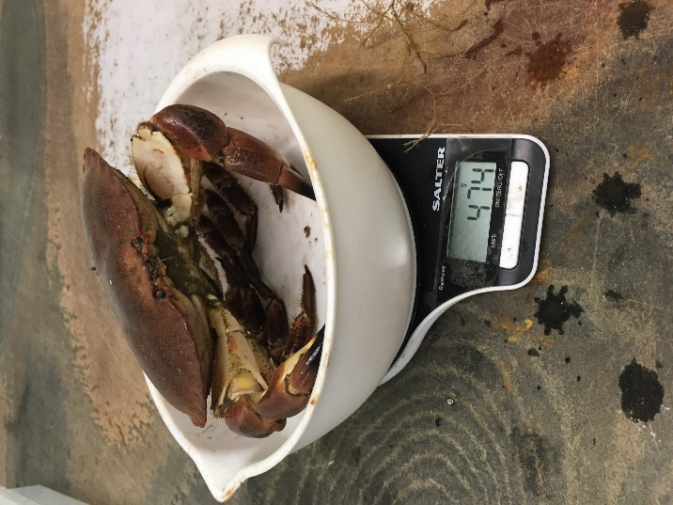

Figure : A female individual during the animal size-weight measurement process.

For the shore-based aspect of this project, biometric data was collected relating to animal size and individual animal weight. Surveys were conducted on *C. pagurus* landed into ports within the NIFCA district, with carapace width (CW) and individual animal weight (g) recorded (Figure 4). Animal size was measured using calibrated Vernier callipers and by weighing each individual animal on scales during the measuring process. This was done to develop an understanding of the relationship between these two factors for both male and female animals. These data were collected from landed individuals and as such, data was only collected from individuals above the MCRS. This allowed for biomass estimates of the overall *C. pagurus* population throughout the various sizes in the population. From the data collected, it was possible to calculate an exponential relationship between animal size (CW) and animal weight for both male and female individuals.

Parameters provided by Cefas, were used to provide estimate of the size of maturity for *C. pagurus* within the NIFCA district. Although this data is not region-specific and is generic to the Central North Sea Stock Unit, spanning from the Scottish Borders to Flamborough Head, it is the most reliable data that is available for this region.

## Offshore sampling

|  |  |
| --- | --- |
| Table : Damage index used during offshore observer trips. | |
| **Damage Score** | **Damage Index** |
| 1 | No visible damage |
| 2 | 1-2 legs missing |
| 3 | >2 legs missing |
| 4 | 1-2 claws missing |
| 5 | Legs and claws missing |
| 6 | Puncture to carapace |

The majority of data used in the stock assessment were collected during offshore trips with onboard fishing industry vessels. Data were collected relating to animal size, sex and condition. Data relating to animal size and sex were collected to understand the individual population dynamics for both male and female *C. pagurus*, with the damage present on each animal recorded to infer an educated estimate of survivorship of those caught and subsequently released. The damage index used during these observational offshore trips can be seen in Table 1. Additional data relating to pot location, soak time, bait type, pot type and weather conditions were also collected to understand the various other factors that may affect catch rates.

## Analysis

From the data collected during these offshore surveys, a Chapman-Robson test was carried out to determine the annual mortality rate. Animal size data collected was separated into age classes, which was calculated using the von Bertalanffy growth curve method, used to estimate animal age based on animal size. From these age classes, the following equation was applied to determine the annual survival rate:

S = T / (N + (T– 1))

S = Annual Survival Rate N = Number of individuals T = Total Recorded Age

From this, to determine annual mortality, the annual survival rate (S) is deducted from 100 to provide total mortality. This provided the overall mortality rate for the population, inclusive of both fishing and natural mortality. Natural mortality (M) is an essential parameter for most stock assessment models (Vetter, 1988), but is difficult to quantify partly due to difficulties associated with aging crustaceans (Bennett, 1978), as natural mortality in crabs is most likely size dependent due to increased risk of mortality when moulting and moult frequency decreases with size/age (Spencer, 2013). Natural mortality has been shown to vary with factors such as age, abundance, fishing pressure, sex and water temperature (Vetter, 1988). Estimates of natural mortality for brown crab range from 0.05 to 0.53 (Spencer, 2013). In stock assessments completed on the *C. pagurus* stock in the Central North Sea stock unit, a value of 0.2 was estimated for M (Cefas, 2017), and as such was used in the assessment carried out by NIFCA. Therefore, fishing mortality was calculated as:

Total Mortality – Natural Mortality (M) = Fishing mortality (F)

For the assessment of the stock status, the appropriateness of this fishing mortality on the current stock was assessed.

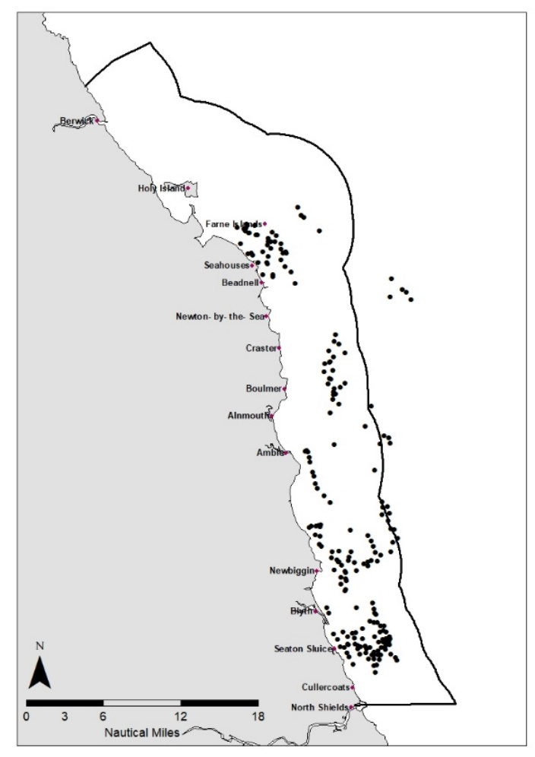

Figure : Spatial distribution of the fleets sampled during offshore surveys.

# Results

Through offshore sampling, 11,811 individuals were measured over a total of 22 trips, with a further 1,874 sampled during the shore-based aspect of this project. The data for these individuals was collected from 225 individual fleets from throughout the NIFCA district. The locations of the fleets that were sampled are shown in Figure 5.

## Size of Maturity

There is very little contemporary, region specific data for the assessment of size of maturity for *C. pagurus* within the NIFCA District. However, for the purposes of this assessment, data was provided from Cefas (Cefas Lawler, 2006 unpubl.) allowing the same parameters to be used for an assessment of maturity within the NIFCA District (Masefield pers. comms., 2019). The following equation was used to model estimates of *C. pagurus* maturity within the NIFCA district, where p is the proportion mature, l is the length of an individual and a and b are the estimated model parameters (Table 2):

Table : The parameters used to calculate *C. pagurus* size of maturity in the NIFCA district.

|  |  |  |
| --- | --- | --- |
| **Sex** | **a** | **b** |
| **Male** | -10.4166 | 0.11634 |
| **Female** | -10.4438 | 0.093592 |

Using the above equation and parameters in Table 2, the modelled maturity estimates for *C. pagurus* are shown in Figure 6 and Table 3.



Figure : Size of sexual maturity estimates for male and female *C. pagurus*, with the carapace width at which 50% of the sampled animals are mature (CW50) displayed (dotted lines). Estimates were calculated using parameters outlined by Cefas for their assesssments (Masefield pers. comms., 2019).

Table : Maturity Estimates for *C. pagurus* within the NIFCA District.

|  |  |  |  |
| --- | --- | --- | --- |
| **Sex** | **50% Mature** | **100% Mature** | **Percentage mature at 130mm MCRS** |
| **Male** | 89.5mm | 136mm | 99% |
| **Female** | 111.6mm | 169mm | 84% |

## Length-Weight Relationship

To determine the relationship between animal size and animal weight, 1,874 animals were sampled. 83 individuals were removed from the analysis because one or two claws were missing so that these anomalous individuals did not impact the dataset. This left an analysed sample size of 1,791 animals, comprising 898 males and 893 females.

At smaller carapace widths (CW), there was a nominal difference in animal weight between sexes (Figure 7 and Table 4). However, as carapace width increases, the difference between the sexes becomes more apparent.

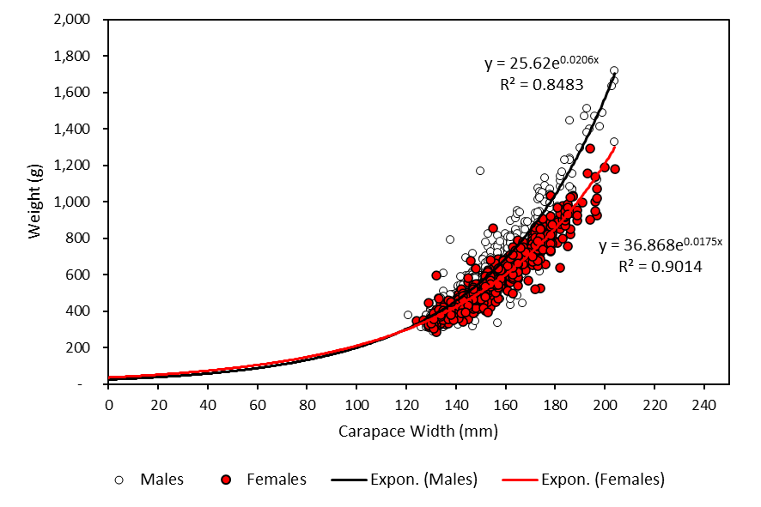

Figure : Size-weight relationships for male and female *C. pagurus* within the NIFCA district, as well as the associated exponential equations for each sex.

Table : Estimated weight in relation to size for male and female *C. pagurus*.

|  |  |  |  |  |
| --- | --- | --- | --- | --- |
| **Sex** | **CW (mm)** | **Weight (g)** | **CW (mm)** | **Weight (g)** |
| **Male** | 130 | 373 | 200 | 1,577 |
| **Female** | 130 | 359 | 200 | 1,221 |

## Survivability

For the purpose of assessing the survivability of the catching process, any animal that did not have a puncture to its carapace is assumed to have survived the process of retention and landing or discarding (Öndes *et al.,* 2016). Lost limbs may in turn contribute to the mortality of *C. pagurus*, however they do not directly result in the mortality of an animal. This was due to the ability of the moulting process of *C. pagurus* facilitating the regeneration of lost limbs. Given this, it is estimated that the survival rate of *C. pagurus*, subject the process of potting, was around 99.4%, with only 69 of the 11,811 animals measured caught being identified as having a puncture to the carapace.

## Population Biometrics

Through the offshore sampling program, a comprehensive understanding of the current population status of *C. pagurus* within the NIFCA district was established. Average male animal size was 135mm, with females averaging 138mm throughout the year. There was a high degree of variation in animal sizes for both male and female individuals, varying from 13-207mm for males and 16-210mm for females (Figure 8). Of all the animals sampled during these offshore surveys, 40% (n=4,698) were under the MCRS of 130mm. Overall, males comprised 51% of the individuals sampled, highlighting a fairly even split in the sex ratio. This was subject to slight monthly variations, with male abundance peaking at 64% in June from a low of 43% in April (Figure 9). Of the females sampled, 29 were observed as egg-bearing, representing 0.01% of females sampled. As previously mentioned, the individuals were separated into age classes to determine the Annual Mortality rate and the subsequent Fishing Mortality (F) the population is currently subject to, thus contributing to the assessment of the stock status.



Figure : Population histograms for both male and female *C. pagurus* sampled during offshore surveys.

Figure : Monthly sex ratios of *C. pagurus* recorded during offshore surveys.



## Stock Status

Following from the analysis of the biometric data collected during offshore surveys and the application of a Chapman-Robson test, the current levels of fishing mortality for both male and female *C. pagurus* within the NIFCA district were higher than the target values for stock sustainability (Figure 10). The sustainability target used for this assessment was based upon the theory of Maximum Sustainable Yield (MSY), with the idea that the preservation of 35% of the viable spawning stock, after fishing pressure and natural mortality have been factored in, would result in a sustainable population (Cefas, 2017 and Seafish, 2019). To plot the relative spawning stock biomass per recruit (SSB/R), the estimates of the expected lifetime reproductive potential of an average recruit, against the exploitation rate (fishing mortality (F)), Thompson & Bell plots were used (Figure 10). The current stock status, as well as the relative changes required to reach the desired MSY targets are shown in Table 5.

Table : Current stock status of male and female *C. pagurus* in the NIFCA district, highlighting the relative changes required to reach MSY.

|  |  |  |  |  |  |
| --- | --- | --- | --- | --- | --- |
| **Sex** | **Current F Value** | **Current SSB/R** | **F at MSY** | **Relative decrease in F required to achieve MSY** | **Relative increase in SSB/R to achieve MSY** |
| **Male** | 0.544 | 0.74 | 0.343 | 0.201 (36.9%) | 0.25 (32.6%) |
| **Female** | 0.531 | 0.62 | 0.352 | 0.179 (33.6%) | 0.18 (29.4%) |

# Discussion



Figure : Thompson & Bell plots displaying relative spawning stock biomass against exploitation rate for both male and female *C. pagurus* in the NIFCA district.

## Size of Maturity

The lack of contemporary and region-specific size of maturity data for *C. pagurus* means there may be some degree of regional variation in size of maturity for the NIFCA district, when compared to the wider Central North Sea stock unit. Despite this, no issue was foreseen with using the data provided from Cefas for this project. More spatially relevant information relating to size of maturity would further add to the robustness of the stock assessment process and permit more accurate and justifiable conclusions and recommendations. It should be noted is that only 85% of the female population within the NIFCA district is thought to be mature at the MCRS. This lack of maturity could indicate that the MCRS for this region is too low, with fisheries science widely stating that an appropriate MCRS allows for an individual to go through multiple breeding cycles before MCRS is reached.

## Length-Weight Relationship

For the length-weight relationship aspect of this project, the data conformed to the expected distribution, with the difference in weight between male and female individuals becoming greater as animal size increased. This likely arises as a consequence of the morphological differences between sexes, with males having far larger claws and thus attaining a greater weight in relation to their associated carapace widths (Haig *et al.,* 2015). The lack of data for individuals below the MCRS highlights a gap in the dataset, this information would allow for a more robust analysis of the overall stock biomass.

## Survivability

*C. pagurus* is widely recognised as having a high rate of survival when discarded, however with a puncture to this carapace, survival rates fall drastically (Veale *et al.*, 2001 and Öndes *et al.,* 2016). Whilst individuals with other forms of damage may also be subject to reduced survivability (Rodrigues *et al.,* 2015). The estimates of survivability for the purposes of this report do not take into account the increased rate of predation of weak and damaged animals that arises as a result (Ramsay and Kaiser, 1998), however worked on the assumption that any animal with a punctured carapace would die when discarded. Whilst this is not specifically true, it would account for the increased subsequent predation mortality that was previously mentioned, as well as any mortality that arose from the loss of limbs. Whilst this data does not directly contribute to the stock assessment process, it is still a valuable source of data to determine the suitability of the current fishing methodologies employed by local fishers.

## Population Biometrics

The population structures for both male and female *C. pagurus* conformed to an expected distribution, with a peak in the population abundance around the MCRS, which then gradually fell as a consequence of fisheries exploitation. This is to be expected in a commercially targeted stock, with animals below this size not subject to the fishing pressures. One of the key limitations to offshore sampling, such as that carried out for this study is the risk of recapture. This can occur when an animal is recorded and discarded on an initial survey and there is no way of knowing when or if this animal is seen again and potentially recorded. This could go some way to skew the data to not show an accurate representation of the population. Despite this, and given the volume of data collected, coupled with the frequency at which such interactions are likely to occur, it is not foreseen that this will result in an inaccurate assessment of the *C. pagurus* stock. Spencer (2013), conducted a mark recapture within the NIFCA district for *C. pagurus*, in which 3.8% of individuals were recaptured. This however accounted for all animals originally being discarded, including above minimum size. Such a high rate of discard has likely inflated the numbers recaptured in this dataset. This does highlight a potential contemporary knowledge gap that could be investigated further.

One limitation of this study is the spatial distribution of the survey effort in the NIFCA district (Figure 5). The lack of surveys in the northern area of the district was as a result of logistical difficulties arising from officer accessibility and location in relation to these ports. Future survey work could focus more on these areas in an effort to ensure a wholescale approach to the stock assessment is adopted. This would help account for any regional differences, despite the relatively small spatial scale of the NIFCA district.

## Stock Status

The status of the *C. pagurus* stock within the NIFCA district conformed to what had previously been reported by Cefas (2017) for the wider central North Sea area, with the SSB/R falling below MSY, as well as fishing mortality exceeding sustainable levels. It is important that future work conducted by NIFCA must work towards achieving MSY and ultimately the sustainability of the stock. Despite these similarities, the Cefas assessment is conducted to include a large spatial area. The region-specific nature of this assessment allows for a more accurate insight into the stock status for the NIFCA district and should be viewed alongisde the Stock Status Reports published by Cefas for the Central North Sea stock unit.

For this assessment, MSY was chosen as the overall target for sustainability. Caddy and Mahon (1995) highlighted the importance of working towards MSY and it’s suitability as a goal for fisheries management. Despite this, there has been some criticism of its appropriateness. Botsford *et al.* (1997), highlighted that MSY did not account for a number of key features and lacked a hollistic approach. The MSY concept has been criticized for its simplified assumptions and considerable range of uncertainty, but more sophisticated data-demanding models, which take into account species interactions and environmental conditions, come with their own problems and uncertainties. As a result, the MSY framework remains the main management tool in most fisheries of the world, with fishing mortality and biomass reference points that correspond to MSYs (Tsikliras and Froese, 2019). On balance, MSY was chosen as the target for the *C. pagurus* fishery of the NIFCA district for it’s simplicity, as well as the ability to compare this with other national stock assemment work that used the same reference points.

It is important to note that the research carried out during this study should not be used as the sole justification for fisheries management. Future monitoring work will add to and build from this baselene and feed into management measures.

# Recommendations

## Future Monitoring

As this is a one-year snapshot into the stock status of the fishery, it is proposed to further this study by repeating this methodology on either an annual or inter-annual basis to detect any changes in stock status. This project can act as a framework for NIFCA to conduct future stock assessment research and provides a baseline for which future stock assessment work can refer to. It also provides an insight into the trends of the fishery.

As a consequence of the lack of region-specific data for the NIFCA district for size of maturity, a further study should be carried out looking into the specific size of maturity for *C. pagurus* within this area. Further to this, the relationship between animal size and weight should be investigated to allow for accurate data to be added to the stock modelling process. Current methods mean that individuals below the minimum size are assigned weights that have not been tested.

## Future Management

Whilst this report must not act as a standalone recommendation document upon which management is evidenced, to achieve MSY, management should still be considered once further stock monitoring work has increased the robustness of this assessment and an overall trend in the fishery status can be observed. To effectively reach MSY for this stock, there are two potential management approaches to take:

* 1. A managed reduction in fishing effort
  2. An increased MCRS

One of the difficulties with fisheries management is that effort limitation is very difficult to implement effectively. For example, a potential further restriction on the pot limit would not necessarily reduce the fishing effort, with this management not specifically limiting the amount of pots that can be hauled. Instead, one potential measure would be to limit the number of days a vessel can fish. This would put a cap on effort; however, this is very difficult to enforce and police effectively and would rely on fishers adhering to the limitations.

A further management method would be to increase the MCRS to a different size. This would mean that a larger percentage of the population would not be subject to fishing pressure and would therefore reduce fishing mortality on the population. This would also bring the MCRS for the NIFCA district into line with neighbouring regions. Currently, the MCRS in Scottish waters to the north of the NIFCA district is 150mm and 140mm to the south in North Eastern IFCA’s district. A proposed increase to a 140mm MCRS would achieve MSY for the fishery and would be far easier to enforce. The impacts of this change on F and SSB/R are shown in Table 6.

Table : Stock status of male and female *C. pagurus* in the NIFCA district with an introduced 140mm MCRS, highlighting that this change would allow the stock to theoretically reach and surpass the MSY target.

|  |  |  |  |  |  |
| --- | --- | --- | --- | --- | --- |
| **Sex** | **F Value at 140mm MCRS** | **Current SSB/R** | **F at MSY** | **Relative decrease in F required to achieve MSY** | **Relative increase in SSB/R to achieve MSY (%)** |
| **Male** | 0.384 | 1.06 | 0.441 | -0.057 (-14.6%) | -0.7 (-6.9%) |
| **Female** | 0.404 | 0.83 | 0.433 | -0.029 (-7.2%) | -0.3 (-3.7%) |

# Conclusions

This project has been very successful and has achieved the aim of assessing the current conservation status of the *C. pagurus* fishery in the NIFCA district. The current stock status falls short of reaching MSY, however with further study and the potential implementation of the management measures set out in section 7.2, in particular the increase of the MCRS, MSY is certainly within reach for the *C. pagurus* fishery of Northumberland. This study has allowed for a comprehensive baseline of the stock status to be established and will act as the foundation for future work.

# References

Bennett, D.B. (1978). Population assessment of the edible crab (*Cancer pagurus* L.) fishery off southwest England. *Rapports et Proces-verbaux des Reunions. Conseil International pour l'Exploration de la Mer*, **175**, 229-235.

Botsford, L.W., Castilla, J.C., and Peterson, C.H. (1997), "The management of fisheries and marine ecosystems" Science 277: 509-515.

Browne, A. (2012). Insight into Fisheries and Enforcement. 2012 Yearly Summary. NIFCA. Available at: <http://www.nifca.gov.uk/wp-content/uploads/2013/11/Insight-to-Fisheries-2012-as-at-10-September-20132.docx>

Caddy, J. F. & Mahon, R. (1995). Reference points for fisheries management. Available at: <http://www.fao.org/docrep/003/V8400E/V8400E00.HTM>

Cefas. (2017). Edible crab (*Cancer pagurus*) Cefas Stock Status Report. Available at: <https://assets.publishing.service.gov.uk/government/uploads/system/uploads/attachment_data/file/722904/Cefas_Crab_Stock_Assessment_2017.pdf>

European Union (EU), (2020). North of Tyne FLAG. Available at: <https://webgate.ec.europa.eu/fpfis/cms/farnet2/on-the-ground/flag-factsheets/north-tyne_en>

Garside, C. J., Edwards, P. M. and Frid, C. L. J. (2004). Fishing effort in the Berwickshire and North Northumberland Coast European Marine Site in 2001-2003. The final report of the Berwickshire and North Northumberland Coast European Marine Site “Sustainable Fisheries Project”.

Haig, J.A.; Pantin, J.R.; Salomonsen, H. & M.J. Kaiser (2015). Size at maturity of the edible crab (*Cancer pagurus*) in Welsh waters. Fisheries & Conservation Science report No 51, Bangor University. Pp.26.

Öndes, F., Kaiser, M.J. and Murray, L.G., (2016). Quantification of the indirect effects of scallop dredge fisheries on a brown crab fishery. *Marine environmental research*, *119*, pp.136-143.

Ramsay, K., Kaiser, M.J., 1998. Demersal fishing disturbance increases predation risk for whelks (*Buccinum undatum L*.). Journal of Sea Research 39, 299-304.

Rodrigues, E., Bell, M. and Mesquita, C., (2015). Discard survival and condition in Orkney brown crabs (*Cancer pagurus*). *Fishing Industry Science Alliance (FISA)*, pp.648-665.

Seafish. (2019). Guide to Fishing at Maximum Sustainable Yield. Available at: <https://seafish.org/media/1570196255-Guide_to_Fishing_at_Maximum_Sustainable_Yield.pdf>

Spencer, A. (2013) An assessment of the Northumberland edible crab Cancer pagurus and velvet crab *Necora puber* fisheries.

Tsikliras, A.C. and Froese, R., (2019). Maximum sustainable yield. *Encyclopedia of Ecology,*, *1*, pp.108-115.

Turner, R. A., Polunin, N. V., & Stead, S. M. (2014). Social networks and fishers' behaviour: exploring the links between information flow and fishing success in the Northumberland lobster fishery.

Veale, L.O., Hill, A.S., Hawkins, S.J., Brand, A.R., (2001). Distribution and damage to the by-catch assemblages of the northern Irish Sea scallop dredge fisheries. Journal of the Marine Biological Association of the U.K. 81, 85-96.

Vetter, E.F. (1988). Estimation of natural mortality in fish stocks: a review. *Fishery Bulletin*, **86**: 25–43.

# Appendix

|  |  |  |  |  |  |  |  |  |  |  |  |
| --- | --- | --- | --- | --- | --- | --- | --- | --- | --- | --- | --- |
| **Appendix A** | | | | | | | | | | | |
| **Fishery Overview** | **2011** | **2012** | **2013** | **2014** | **2015** | **2016** | **2017** | **2018** | **2019** | **Value Ref** | **Data Source** |
| Total Landings (NIFCA) | *529.6* | *621.3* | *782* | *861.7* | *859.3* | *1,002.3* | *1,056.6* | *977.1* | *949.5* | Tonnes | NIFCA Returns |
| Amble Landings | *106.4* | *170.6* | *220.8* | *281.4* | *175.7* | *205.4* | *241.2* | *213.9* | *163.7* | Tonnes | NIFCA Returns |
| Blyth Landings | *32.5* | *42.5* | *56.3* | *112.6* | *105.0* | *161.8* | *100.9* | *92.8* | *160.7* | Tonnes | NIFCA Returns |
| Holy Island Landings | *102.2* | *131.2* | *124.1* | *105.0* | *167.1* | *253.2* | *269.8* | *200.1* | *196.5* | Tonnes | NIFCA Returns |
| Seahouses Landings | *114.7* | *130.2* | *132.5* | *133.7* | *159.5* | *122.4* | *196.3* | *190.9* | *185.7* | Tonnes | NIFCA Returns |
| Total Effort (Hauled) | *2.79* | *2.63* | *2.89* | *3.14* | *3.02* | *3.12* | *2.91* | *2.89* | *3.12* | Million | NIFCA Returns |
| Total Effort (Pots Set) | *33.33* | *32.82* | *35.22* | *37.98* | *36.58* | *33.80* | *34.39* | *35.94* | *37.74* | Thousand | NIFCA Returns |
| Q1 Catch Distribution  (% of Annual Total) | *16%* | *23%* | *21%* | *26%* | *19%* | *27%* | *26%* | *23%* | *32%* | Q1 % | NIFCA Returns |
| Q2 Catch Distribution  (% of Annual Total) | *27%* | *28%* | *25%* | *26%* | *27%* | *21%* | *22%* | *25%* | *25%* | Q2 % | NIFCA Returns |
| Q3 Catch Distribution  (% of Annual Total) | *27%* | *18%* | *29%* | *23%* | *26%* | *25%* | *23%* | *28%* | *21%* | Q3 % | NIFCA Returns |
| Q4 Catch Distribution  (% of Annual Total) | *30%* | *31%* | *26%* | *25%* | *28%* | *28%* | *29%* | *24%* | *22%* | Q4 % | NIFCA Returns |
|  | | | | | | | | | | | |
| **Primary Reference Points** | **2011** | **2012** | **2013** | **2014** | **2015** | **2016** | **2017** | **2018** | **2019** | **Value Ref** | **Data Source** |
| Annual Mortality Rate - Males | *x* | *x* | *x* | *x* | *x* | *x* | *x* | *x* | *54.4* | % | CR - OS sampling |
| Annual Mortality Rate - Females | *x* | *x* | *x* | *x* | *x* | *x* | *x* | *x* | *53.1* | % | CR - OS sampling |
| LPUE | *19.89* | *26.12* | *29.19* | *30.84* | *29.84* | *34.81* | *39.04* | *35.57* | *34.15* | KG/100ph | NIFCA Returns |
|  | | | | | | | | | | | |
| **Economic** | **2011** | **2012** | **2013** | **2014** | **2015** | **2016** | **2017** | **2018** | **2019** | **Value Ref** | **Data Source** |
| Average Annual Price | *1.19* | *1.19* | *1.17* | *1.19* | *1.15* | *1.17* | *1.30* | *1.65* | *2.25\** | £ | NIFCA IFCO Reports* |
| Gross Catch Value | *0.63* | *0.74* | *0.91* | *1.03* | *0.99* | *1.18* | *1.39* | *1.61* | *2.14* | £ Million | NIFCA Returns |
| No. Active Vessels | *81* | *72* | *83* | *80* | *75* | *70* | *73* | *85* | *74* | # | NIFCA Returns |
| No. Employment** | *170* | *151* | *174* | *168* | *158* | *147* | *153* | *179* | *156* | # | Effort Survey |
|  | | | | | | | | | | | |
| **Biometric** | **2011** | **2012** | **2013** | **2014** | **2015** | **2016** | **2017** | **2018** | **2019** | **Value Ref** | **Data Source** |
| Average Carapace Length M (mm) | *x* | *x* | *x* | *x* | *x* | *x* | *x* | *x* | *135* | mm | NIFCA Survey |
| Average Carapace Length F (mm) | *x* | *x* | *x* | *x* | *x* | *x* | *x* | *x* | *138* | mm | NIFCA Survey |
| Max Carapace Length M (mm) | *x* | *x* | *x* | *x* | *x* | *x* | *x* | *x* | *210* | mm | NIFCA Survey |
| Max Carapace Length F (mm) | *x* | *x* | *x* | *x* | *x* | *x* | *x* | *x* | *207* | mm | NIFCA Survey |
| Sex Ratio (% Female) | *x* | *x* | *x* | *x* | *x* | *x* | *x* | *x* | *48.5* | % | NIFCA Survey |
|  | | | | | | | | | | | |

*This was taken from IFCO reports for 2019 only rather than MMO landings data. This is to provide a region-specific value for the NIFCA brown crab fishery.

**This is calculated by using an approximate crew number of 2.1 per vessel throughout the district. This is taken from a 2019 Effort Report by officers.